


present best-selling author
R.J. Palacio
Wednesday, October 16th, 6pm
HEATHERWOOD MIDDLE SCHOOL

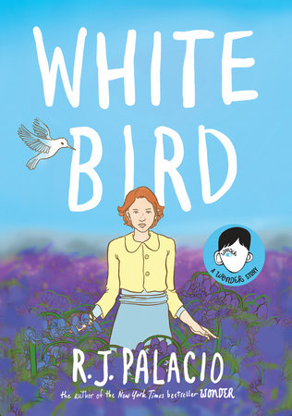
About White Bird: Inspired by her blockbuster phenomenon Wonder, R. J. Palacio makes her graphic novel debut with an unforgettable story of the power of kindness and unrelenting courage in a time of war.

In R. J. Palacio's bestselling collection of stories Auggie & Me, which expands on characters in Wonder, readers were introduced to Julian's grandmother, Grandmère. Here, Palacio makes her graphic novel debut with Grandmère's heartrending story: how she, a young Jewish girl, was hidden by a family in a Nazi-occupied French village during World War II; how the boy she and her classmates once shunned became her savior and best friend.
Sara's harrowing experience movingly demonstrates the power of kindness to change hearts, build bridges, and even save lives. As Grandmère tells Julian, "It always takes courage to be kind, but in those days, such kindness could cost you everything." With poignant symbolism and gorgeous artwork that brings Sara's story out of the past and cements it firmly in this moment in history, White Bird is sure to captivate anyone who was moved by the book Wonder or the blockbuster movie adaptation and its message.

About R.J. Palacio: R. J. Palacio lives in New York City with her husband, two sons, and two dogs. For more than twenty years, she was an art director and graphic designer, designing book jackets for other people while waiting for the perfect time in her life to start writing her own novel. But one day several years ago, a chance encounter with an extraordinary child in front of an ice cream store made R.J. realize that the perfect time to write that novel had finally come. Wonder is her first novel. She did not design the cover, but she sure does love it.

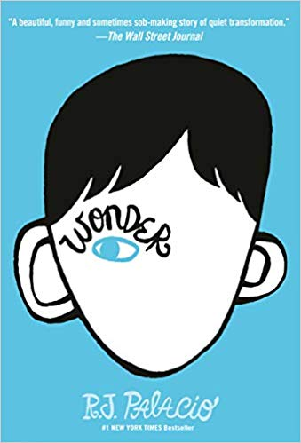
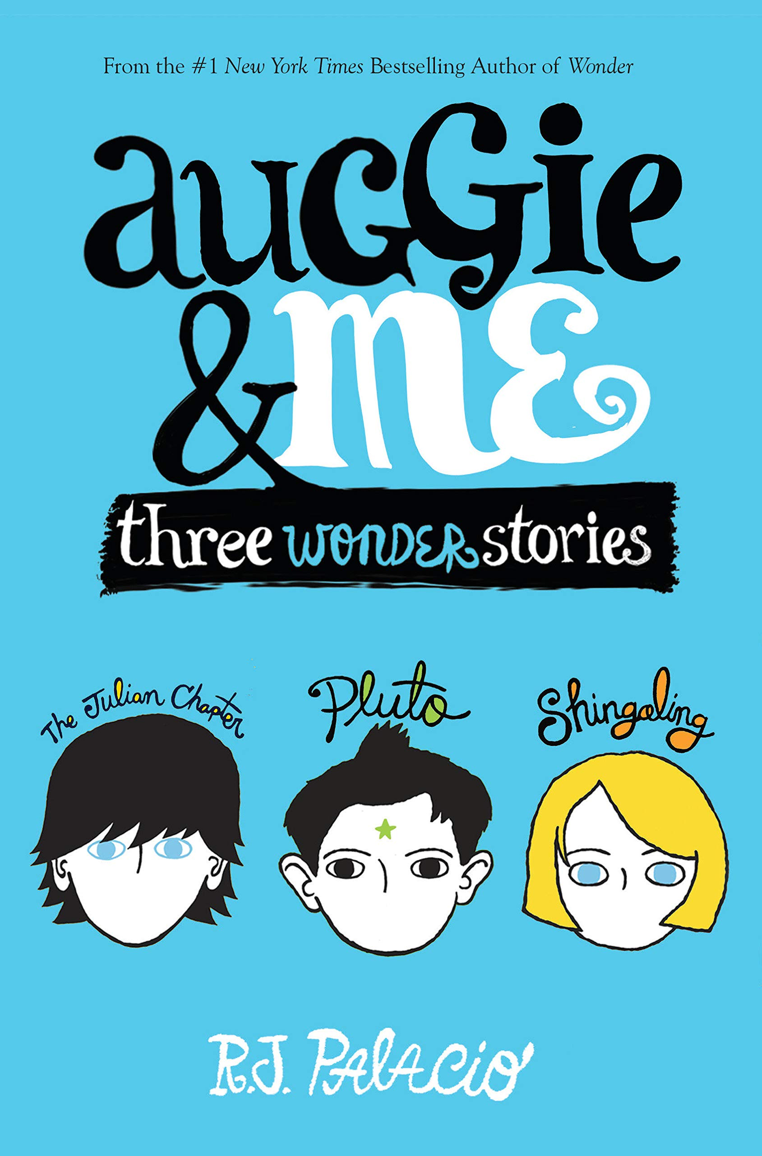
To pre-purchase and reserve a book for the author to sign at the event, please fill out the attached order form and return to your teacher or librarian by:
Tuesday, October 1st

A limited amount of books will be available for purchase at the event.

University Book Store thanks you for supporting your local, independent businesses! Your book purchases through this order form allow us to bring great author experiences to our schools and community free of charge. Thank you!


University Book Store, Inc.
Book Order Form

Student Name: __________________________________
Parent Name:
Phone Number: __________________________________
School: _________________________________________
ELA Teacher: ____________________________________

Quantity | Book Title | Price (tax is included in price shown) | Line Total
 | White Bird | $27.61
 | Wonder | $18.77
 | Auggie & Me: Three Wonder Stories | $18.77
 |  | TOTAL

IMPORTANT EVENT NOTE:
Preordered books can be picked up at the event on October 16th. Line up after the author talk to have her sign & personalize your book.
All orders not picked up at the event will be signed (not personalized) and returned to the student’s school.
Books from home can be brought to Heatherwood Middle School for signing during the event only.

Please check your payment type and enclose Cash or Check for the total amount.
Pay to the order of: University Book Store

Cash _______ Check _______

Credit Card payments also accepted by calling University Book Store in Mill Creek (425)385-3530

